Arushi
23BCC70014
EXPERIMENT-2
AIM
To design and develop a responsive banking user interface using
only HTML and CSS, which includes a balance display, deposit
button, and withdraw button.
OBJECTIVE
- Practice modern layout techniques using HTML and CSS.
- Create a responsive and visually clean UI that works on desktops,
tablets, and mobile devices.
- Apply design principles like alignment, spacing, and centering
using Flexbox and media queries.
THEORY
HTML and CSS provide powerful tools for building visually
appealing and responsive interfaces. In this task:
- HTML structures the content (balance, buttons).
- CSS Flexbox centers content both vertically and horizontally and
manages layout.
- Media queries make the layout responsive across different screen
sizes.
- The UI must be static—no interactivity with JavaScript.
CODE
<!DOCTYPE html>
<html lang="en">
<head>
<meta charset="UTF-8">
<title>Banking UI</title>
<meta name="viewport" content="width=device-width, initial-scale=1.0">
<style>
* {
box-sizing: border-box;
}
body {
font-family: Arial, sans-serif;
background-color: #f0f2f5;
margin: 0;
padding: 0;
display: flex;
align-items: center;
justify-content: center;
height: 100vh;
}
.bank-ui {
background-color: white;
padding: 30px;
border-radius: 10px;
box-shadow: 0 4px 8px rgba(0,0,0,0.1);
text-align: center;
width: 300px;
}
.balance {
font-size: 24px;
font-weight: bold;
color: #333;
margin-bottom: 20px;
padding: 15px;
border: 2px solid #4CAF50;
border-radius: 5px;
}
.button-group {
display: flex;
justify-content: space-between;
gap: 10px;
}
button {
padding: 10px;
flex: 1;
background-color: #4CAF50;
color: white;
border: none;
border-radius: 5px;
cursor: default;
}
@media (max-width: 500px) {
.bank-ui {
width: 90%;
}
.button-group {
flex-direction: column;
}
}
</style>
</head>
<body>
<div class="bank-ui">
<div class="balance">Balance: ₹50,000</div>
<div class="button-group">
<button>Deposit</button>
<button>Withdraw</button>
</div>
</div>
</body>
</html>
OUTPUT

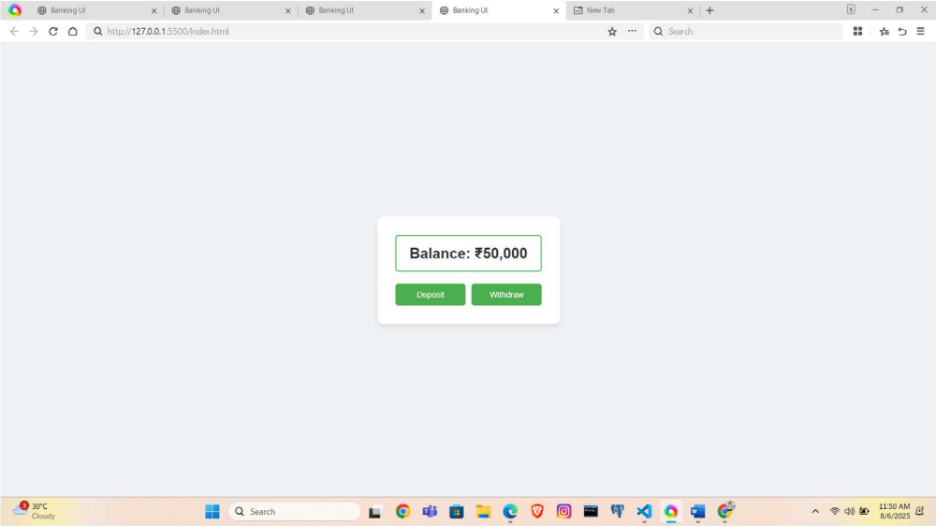

LEARNING OUTCOME
- Use Flexbox for layout and centering.
- Build responsive web interfaces using media queries.
- Style HTML elements professionally using modern CSS practices.
- Create clean, structured UI components without using JavaScript.

